**SESSION -7**

**ADD ION OF NEW CONSTRAINT:**

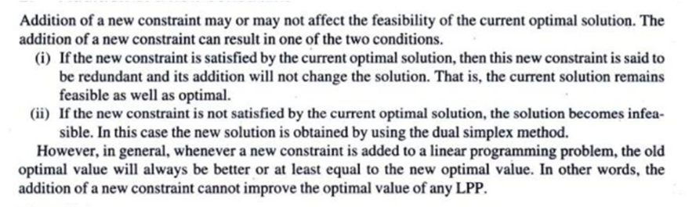

EX:

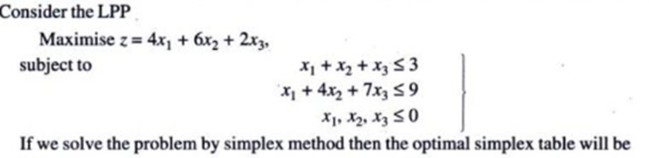

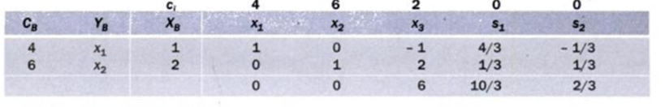



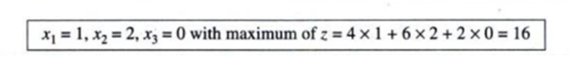



Doesnot satisfy the additional constraint.The current optimal solution is not optimal for the modified problem. Let S3 be the slack variable for the new constraint the modified table will be

